**EventVista Project Report**

**1. Real World Problem Identification**

The real-world problem identified is the need for efficient event management, where users can create, edit, and delete events, as well as schedule notifications for these events. Organizing events, whether personal or professional, can be challenging, and people often miss important deadlines or appointments. This problem affects individuals, organizations, and communities.

Event management is crucial in various domains, such as personal calendars, business meetings, social gatherings, and more. Inefficient event management can result in missed opportunities, scheduling conflicts, and confusion.

**2. Proposed Solution**

The proposed solution is an Event Management Application that allows users to manage their events seamlessly. Users can create, edit, and delete events with ease, and they can also schedule notifications to receive timely reminders.

Goals and Objectives:

- Provide a user-friendly interface for event management.

- Allow users to create, edit, and delete events effortlessly.

- Enable users to schedule notifications for events.

- Improve overall time management and reduce missed events.

Innovative Aspects:

The application aims to stand out with features such as intuitive event creation, flexible event editing, and efficient notification scheduling, making it a comprehensive solution for event management needs.

3. **Responsive User Interfaces (Screenshots of app)**

Splash screen:

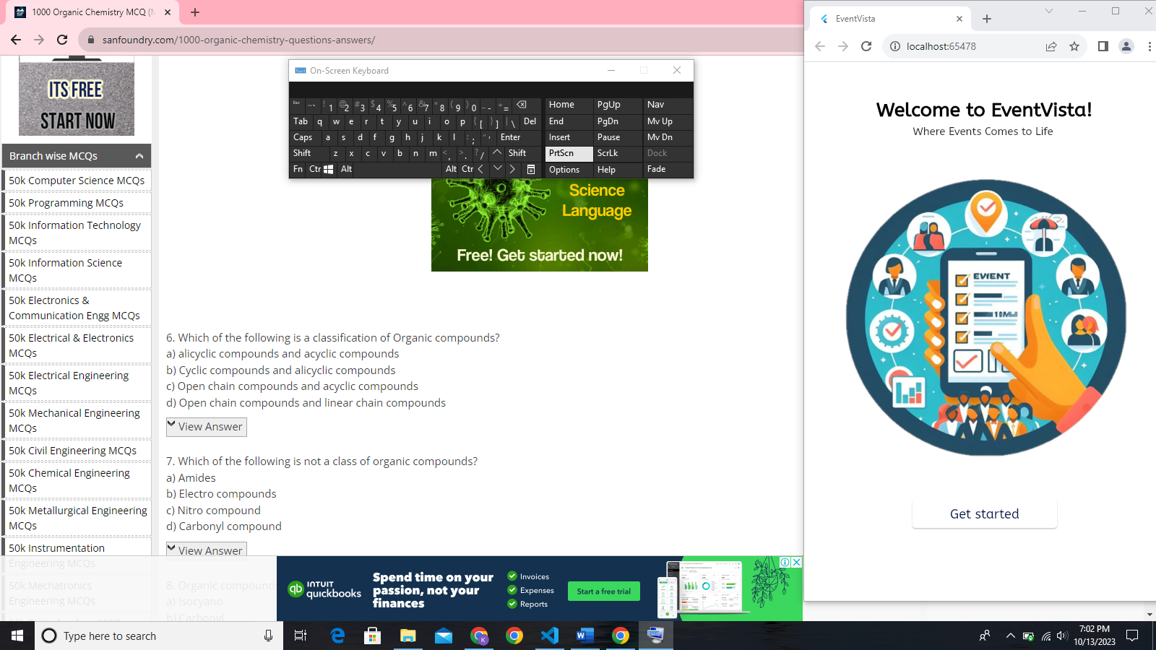

login and signup:

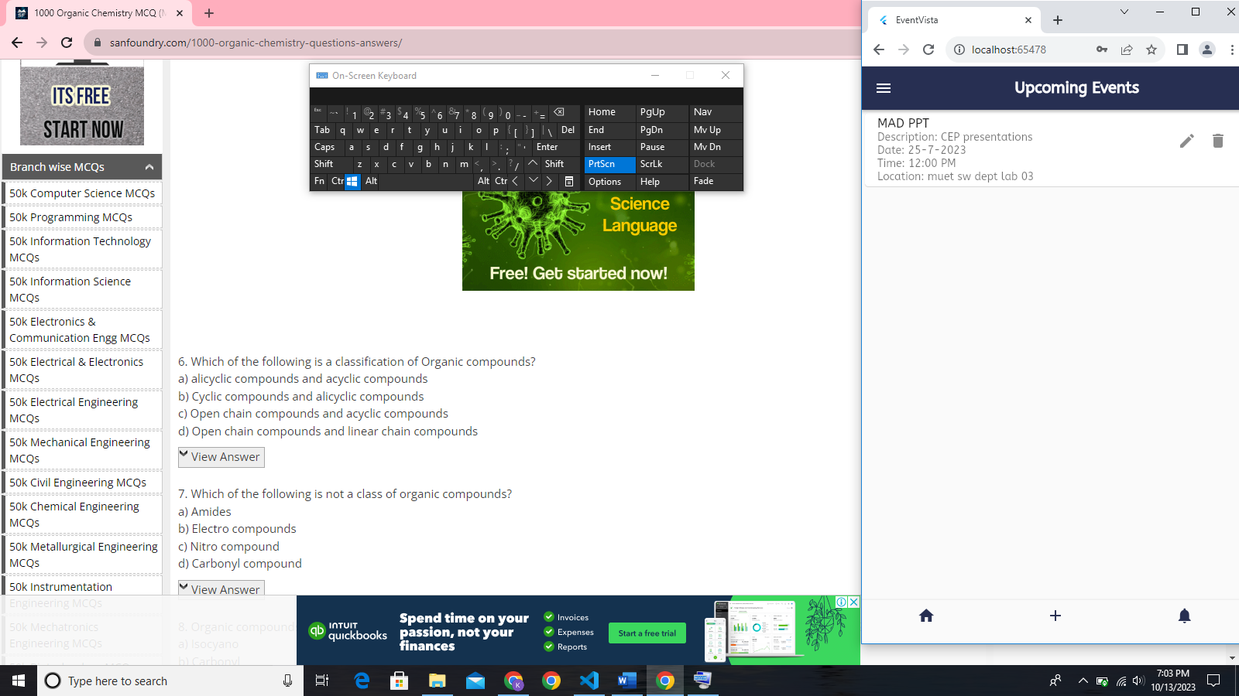Profile details: Home screen (display upcoming events)

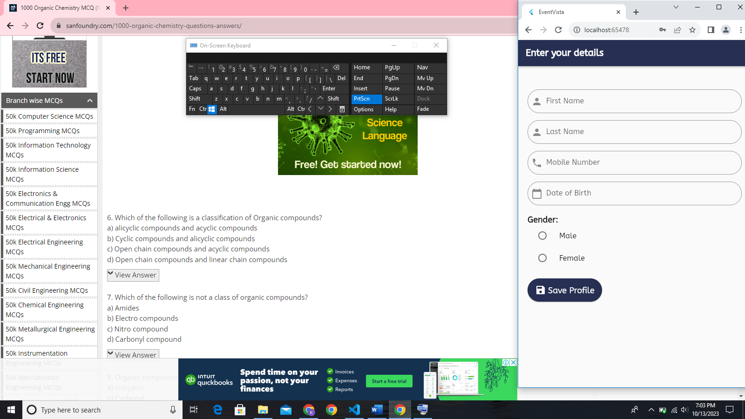s

Create event: Edit event:

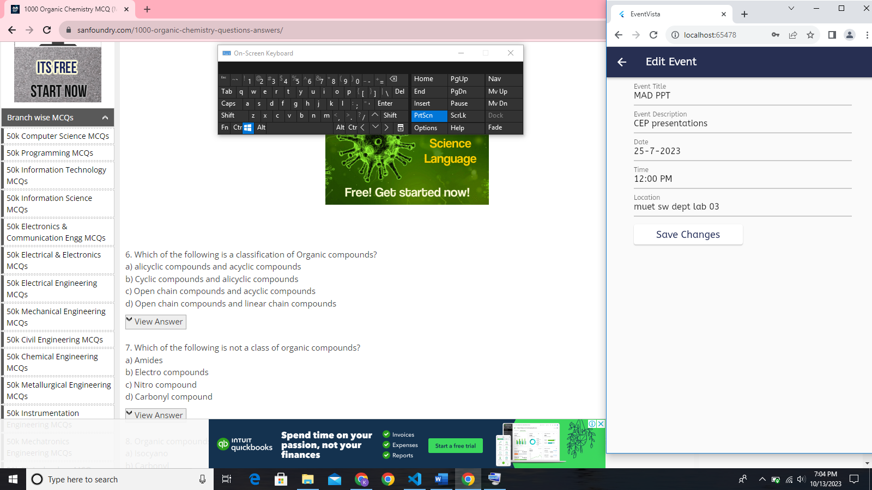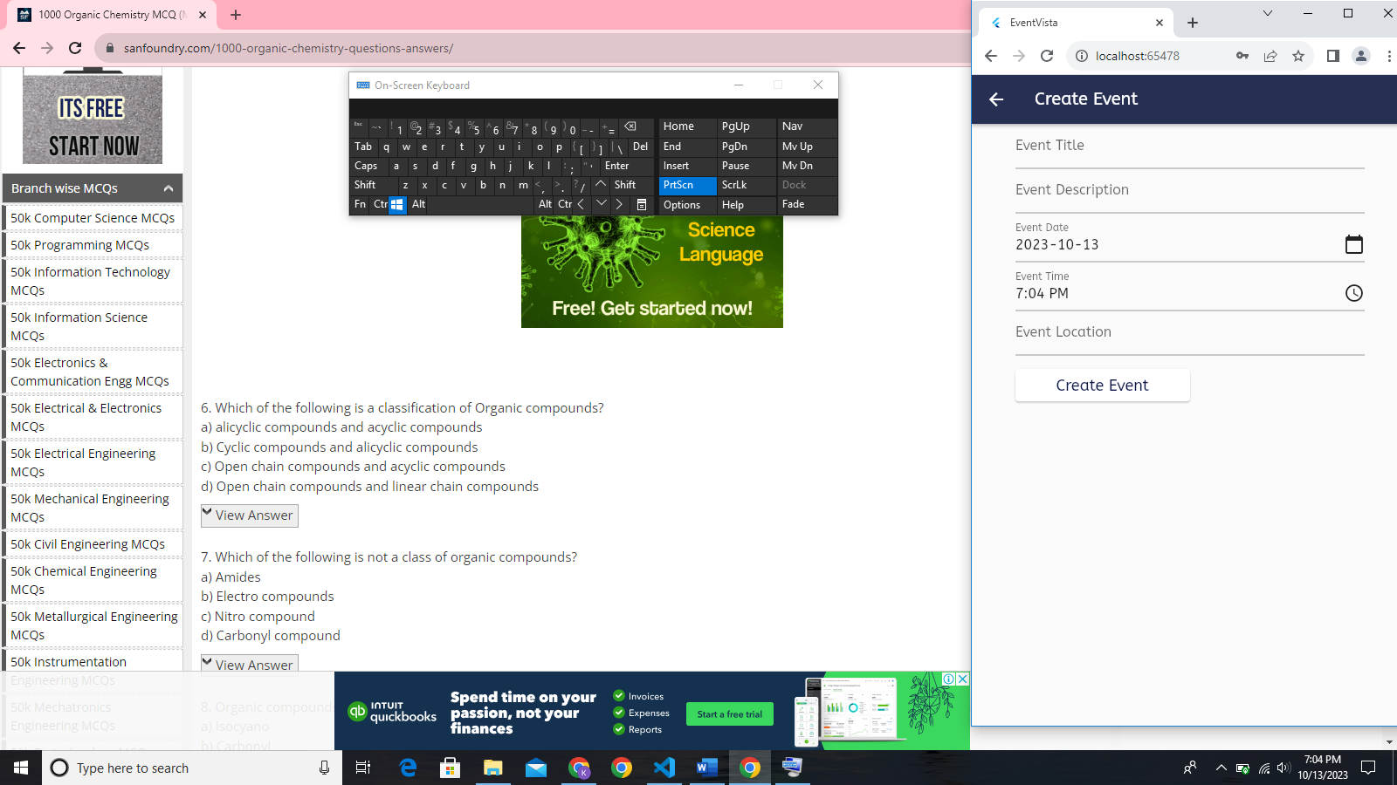

Event notification: logout:

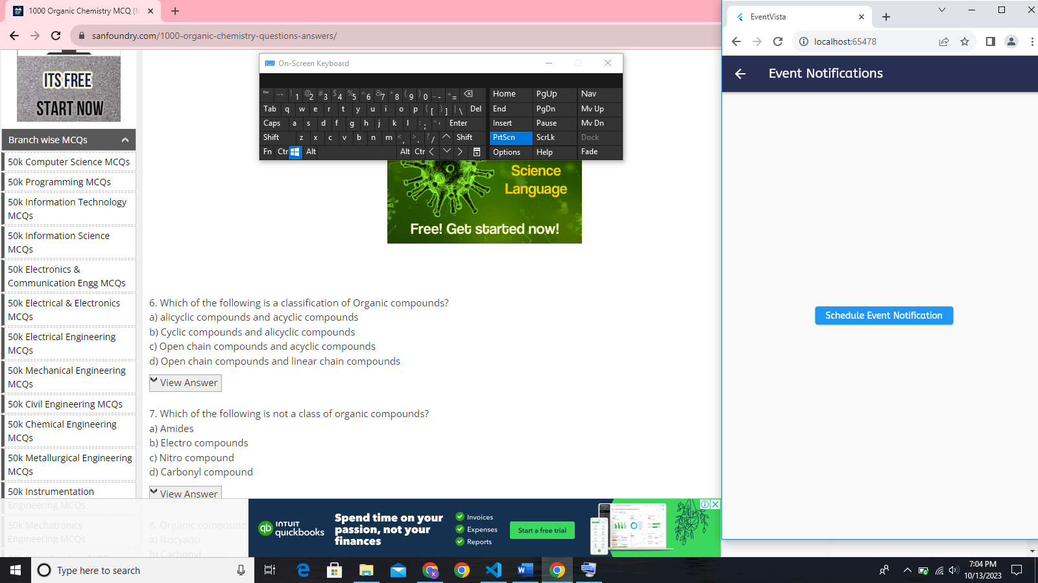

**4. Data Storage (With justification for using a particular database)**

**Database Choice:** Firebase Realtime Database

Justification:

* **Real-Time Data Sync**: Firebase Realtime Database ensures real-time synchronization, a critical feature for an event management app. Users can instantly access and update event data, enabling seamless collaboration among multiple users.
* **Scalability:** Hosted in the cloud, Firebase offers automatic scaling as EventVista grows. It can handle increased data and user load without the need for complex server infrastructure management, ensuring optimal performance as the app expands.
* **No Server-Side Code**: Firebase eliminates the need for extensive server-side code, simplifying development efforts. This allows the development team to focus on the user experience and frontend development, saving time and resources.
* **Cross-Platform Compatibility:** Firebase provides SDKs for various platforms, allowing a consistent user experience across web, Android, and iOS. Users can access EventVista on their preferred devices, enhancing accessibility.
* **Authentication and Security:** Firebase offers built-in user authentication and customizable security rules. This ensures that only authorized users can access and modify event data, providing robust data protection.
* **Cross-Platform Notifications:** Firebase Cloud Messaging (FCM) integration enables EventVista to send notifications about upcoming events and changes. This feature keeps users informed, an asset for an event management application.

**5. APIs/Packages/Plug-ins (if used with justifications for using them)**

**1. `get` Package:** Used for lightweight and efficient state management, simplifying data fetching and management. This package enhances the application's reactivity and allows to manage app state effectively.

**2. `google_fonts` Package:** Enables the use of custom fonts to improve the app's design and visual appeal.

**3. `firebase_core` Package:** Essential for initializing Firebase services, including authentication and Firestore.

**4. `firebase_auth` Package:** Provides user authentication and data security, ensuring that only authorized users can access and modify event-related information.

**5. `firebase_storage` Package**: Manages the storage of images and files, ensuring secure and scalable storage for event-related media assets.

**6. `cloud_firestore` Package**: Facilitates real-time data storage and retrieval, crucial for core functionalities like event creation, editing, and viewing in EventVista.

These tools and packages collectively support user authentication, data management, state management, data fetching, and enhanced app design in EventVista.

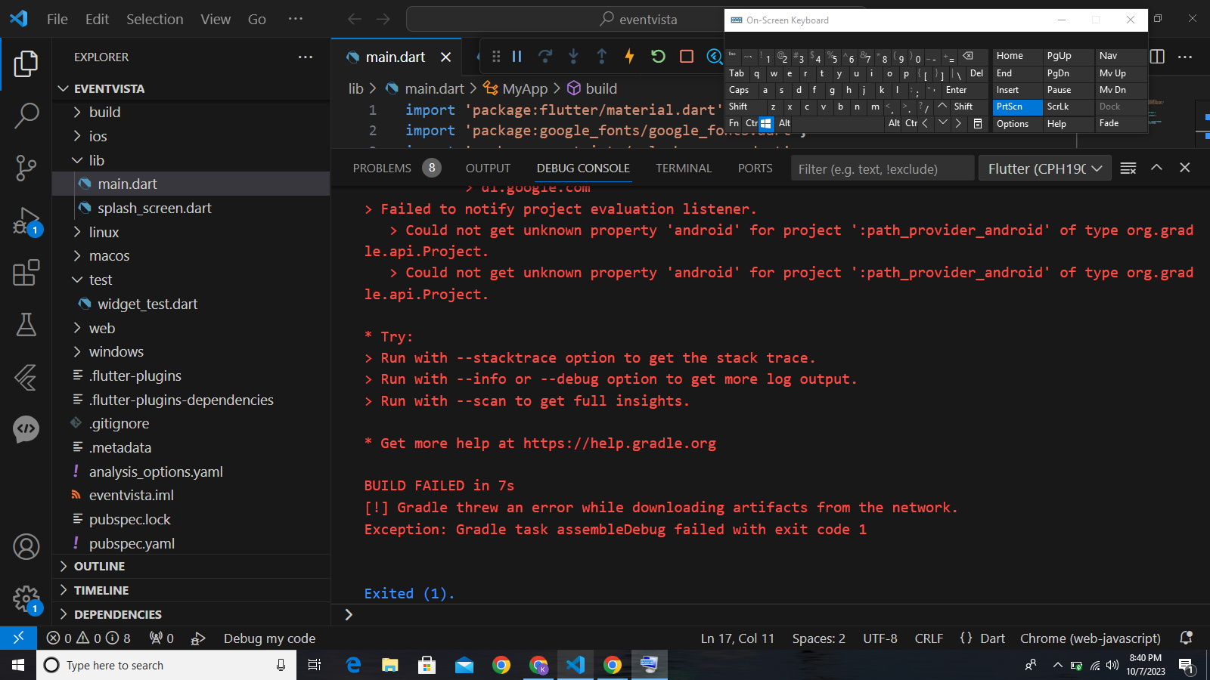**6. Issues and Bugs Encountered and Resolved during Development**

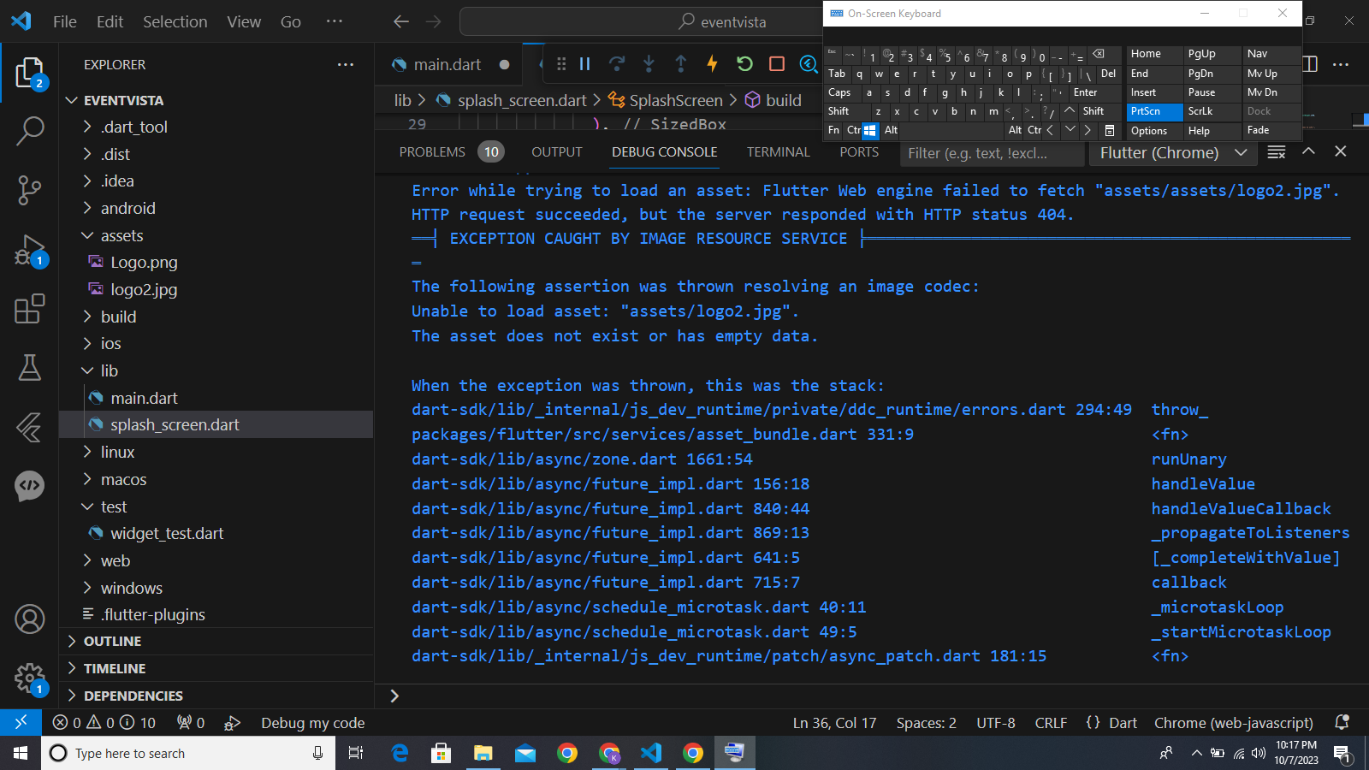

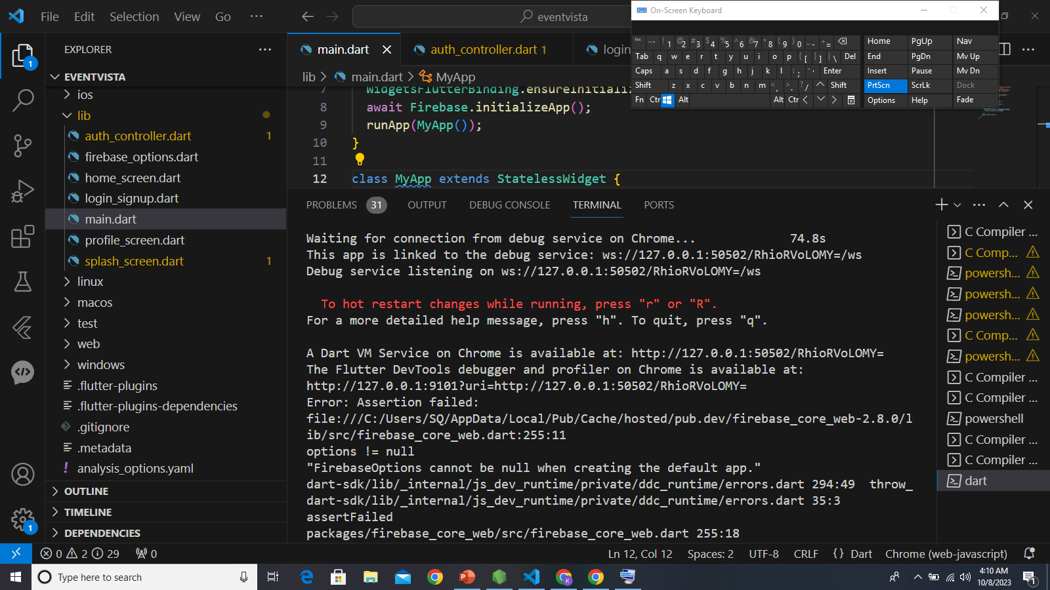

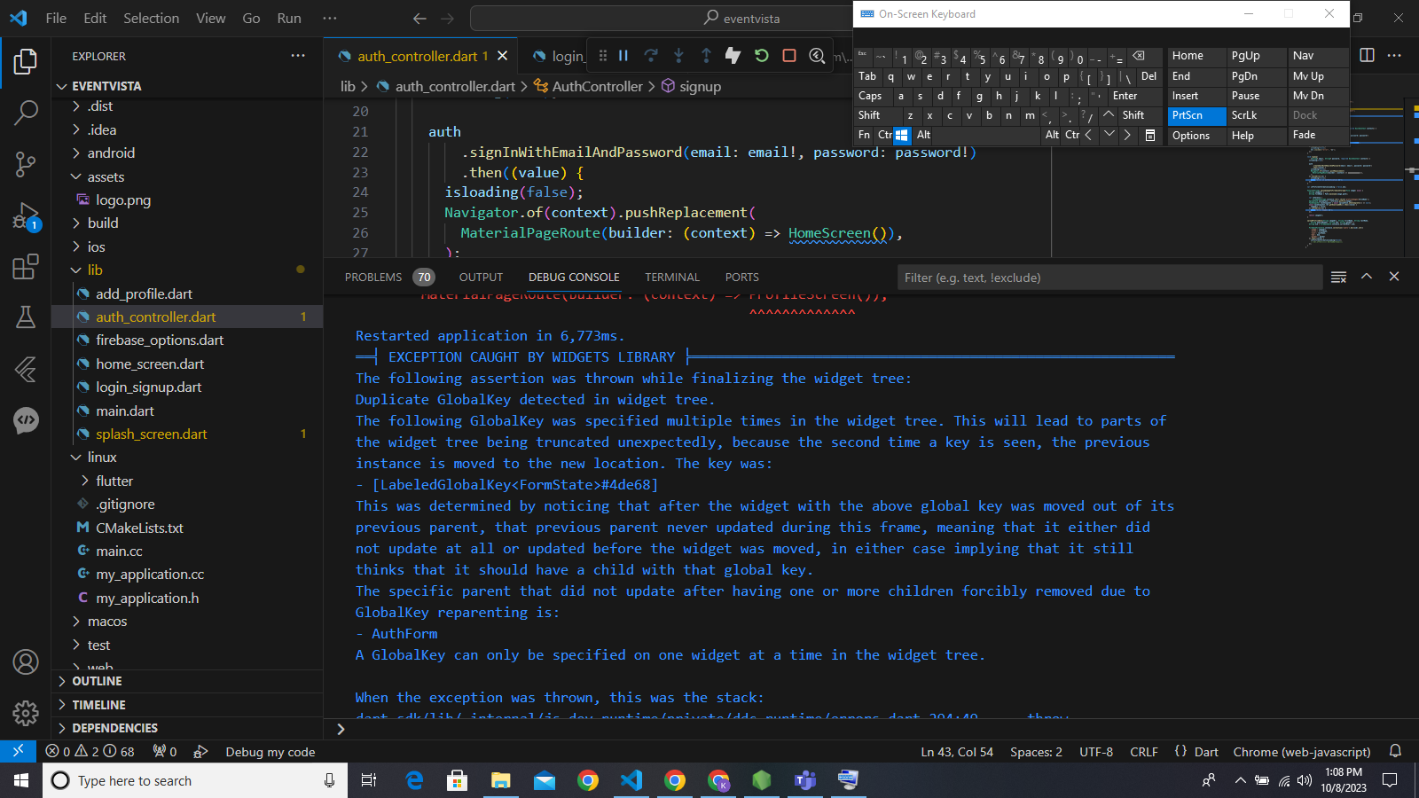

**Conclusion**

In conclusion, the Event Management Application addresses the real-world problem of efficient event management. It offers a user-friendly solution with responsive interfaces, efficient data storage, and optional external tools to enhance its functionality. During development, various issues were encountered and successfully resolved, contributing to the overall quality of the application.

Future Plans:

1. Enhanced Event Discovery: Improve personalized event recommendations.

2. In-App Social Interaction: Foster attendee connections and engagement.

3. Interactive Event Engagement: Add live polling and Q&A features.

4. Advanced Analytics: Provide organizers with deeper attendee insights.

5. E-Tickets and Check-In: Simplify event registration and attendance management.

6. Event Documentation: Offer access to event photos, videos, and resources.

7. Streamlined Feedback and Surveys: Gather post-event feedback for improvement.

8. Certificate Management: Streamline digital certificate issuance.

9. Accessibility Improvements: Ensure accessibility for all users.

10. Platform Expansion: Explore additional platform options.

These plans aim to enhance event management, making it more accessible and engaging for all users, while providing valuable tools for event organizers.